SQL basics: Task 1

**Useful Info:**

First, check this documentation for the topics marked by the red “v” sign. They can be useful when you do the exercise.

<https://www.w3schools.com/sql/default.asp>

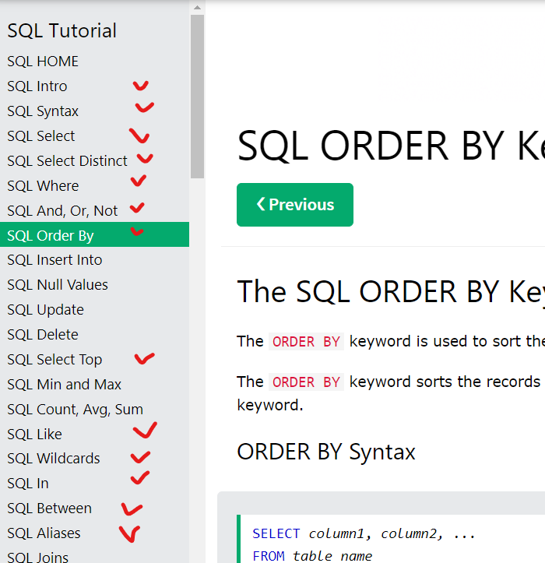

**Exercise:**

Write SQL queries using HR schema data for:

1. Ten tasks below
2. Task 5 from **SQL.pdf file**

As a result, you need to have:

1. Task1_<Name_Surname>.sql file
2. Task1_<Name_Surname>.docx file with screenshots of query results

Commit your files to “Result” folder under “Task 1” folder.

To DO tasks:

**Task 1**

Create a query to display all the data from the *Employees* table.

**Task 2**

Create a query to display the department number, department name, and manager number. Name the last column (manager number) heading as “MNG”

**Task 3**

Create a query to display the employee number, first name, last name, phone number and department number

**Task 4**

Create a query to display the first name, last name, hire date, salary, and salary after a raise of 20%. Name the last column (salary after a raise) heading as “ANNUAL_SAL”

**Task 5**

Create a query to display the last name concatenated with the first name, separated by space, and the telephone number concatenated with the email address, separated by hyphen. Name the column headings “FULL_NAME” and “CONTACT_DETAILS” respectively (*Employees* tables).

**Task 6**

Create a query to display the unique manager numbers from *Employees* table.

**Task 7**

Create a query to display the last name concatenated with *job_id* column, separated by space. Name this column heading as “EMPLOYEE_AND_TITLE”

**Task 8**

Create a query to display the first name, last name, salary, and hire date concatenated with the literal string “HD”, separated by space. Name the column headings “FN”, “LN”, “SAL”, and “HD” respectively

**Task 9**

Create a query to display the unique salaries in *Employees* tables.

**Task 10**

Create a query to display the unique combination of values in *department_id* and *job_id* columns (*Employees* table).